In the exercise *Adding data to a worksheet*, you added data to a worksheet named **Sheet1.** You first downloaded and opened the Excel file. You then verified and corrected the existing information within **Sheet1**. Next, you formatted the data, then added new information to the workbook. Finally, you managed the worksheet and renamed it **Sample Figures**. You also added a second worksheet called Exchange Rates.

Your final workbook should resemble the following screenshots:

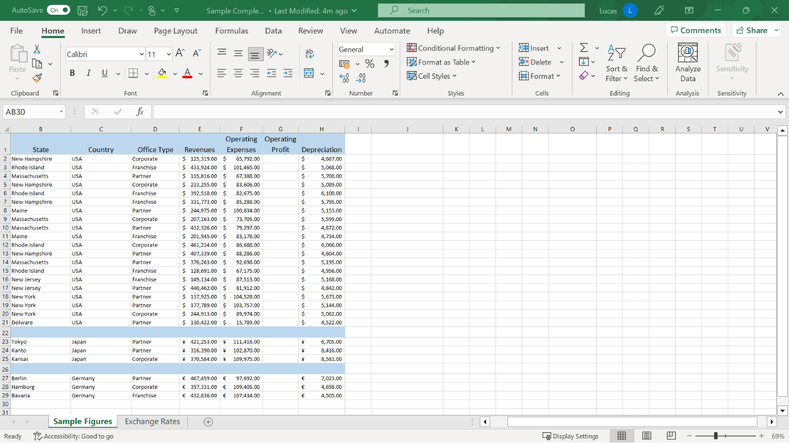

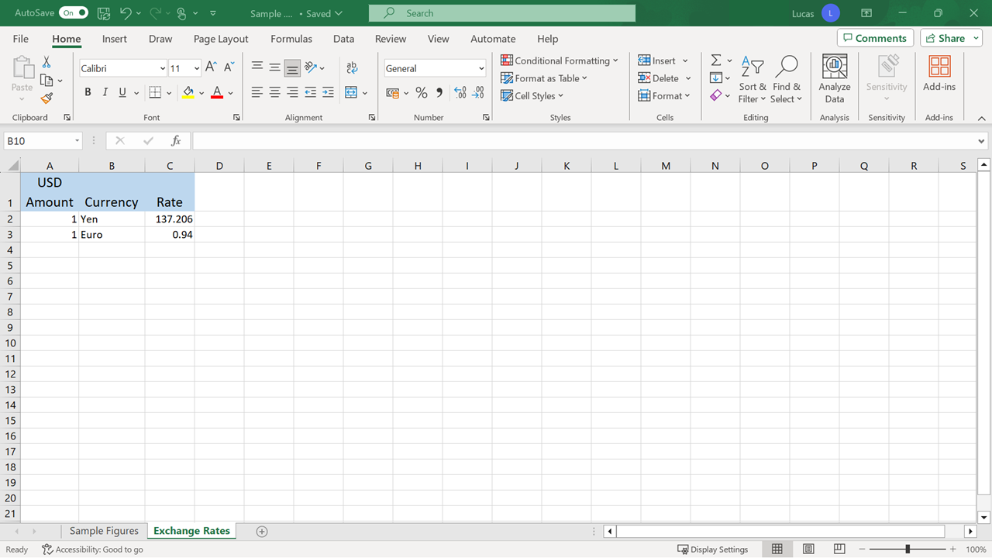

Now it’s time to review your understanding of the tasks you completed by answering the questions that follow. Don’t forget that you can revisit the previous learning items to recap the process steps.

**1.**

Question 1

In **Sheet1**, Microsoft Excel automatically aligned a numerical entry to the left. In this case, such an action indicates an issue with the content. How can you correct an error like this?

Change the alignment.

Alter the **Number format**.

Edit the content.

Status: [object Object]

1 point

**2.**

Question 2

In step 3, you formatted cells **E23** to **H25**, which contained figures representing Japanese Yen amounts. What steps did you take to apply the Yen **Currency format** to this block of cells?

Select the **Currency button** in the **Number** section of the **Home** tab. Choose **More Accounting Formats**. With **Currency** highlighted as a category, select the **Symbol** drop-down on the right. Select **Japanese** from the list of currencies that appear.

Select the **Currency** button in the **Number** section of the **Home** tab. Choose **More** **Accounting Formats**. With **Custom** highlighted as a category, select the **Symbol** drop-down on the right. Select **Japanese** from the list currency symbols that appear.

Select the **Currency** button in the **Number** section of the **Home** tab. Choose **More** **Accounting Formats**. With **Special** highlighted as a category, select the **Symbol** drop-down on the right. Select **Japanese** from the list of currency symbols that appear.

Status: [object Object]

1 point

**3.**

Question 3

As one of the final steps in the exercise, you hid the **Contacts** worksheet using the **Hide & Unhide** command. Where on the **Home** tab is this command located?

On the **Format** choice in the **Styles** group.

On the **Format** choice in the **Cells** group.

On the **Format** choice in the **Editing** group.